**Machine Learning Algorithm for Soil Analysis and Classification of Micronutrients in IoT-Enabled Automated Farms**

**Abstract:**

Soil health plays a critical role in agricultural productivity, especially in the context of IoT-enabled automated farms where precision farming is emphasized. With the growing need for sustainable practices and higher yield, understanding the soil's micronutrient composition is essential. This paper presents a machine learning-based approach for analyzing and classifying soil micronutrient levels to facilitate decision-making in automated farming systems. The proposed system leverages IoT devices for real-time data collection, allowing farmers to monitor soil health continuously. By integrating IoT with machine learning algorithms, we aim to create a dynamic model that adapts to varying environmental conditions, thereby improving the accuracy of soil health assessments.

Our approach involves collecting soil data through IoT sensors, such as pH, moisture, and nutrient levels, which is then preprocessed to eliminate noise and ensure data quality. Various machine learning algorithms, including decision trees, support vector machines, and neural networks, are applied to classify soil samples based on their micronutrient content, such as nitrogen, phosphorus, potassium, and trace elements. The classification model is trained on labeled data to recognize patterns and correlations among different soil properties and their nutrient levels, enabling the system to predict micronutrient deficiencies effectively.

Results indicate that the proposed model significantly improves the accuracy of soil nutrient classification, with high reliability across diverse soil types. This system’s real-time capabilities enable prompt corrective actions, such as adjusting fertilization or irrigation practices, thereby optimizing crop yield while minimizing environmental impact. Furthermore, the integration of explainable AI techniques allows stakeholders to understand and trust the model's decision-making process, ensuring transparency in farm management. This research contributes to the development of intelligent farming solutions that support sustainable and efficient agriculture, paving the way for more adaptive and resource-efficient farming practices.

**Introduction:**

In the era of precision agriculture, understanding soil composition and nutrient levels is essential for improving crop yields and promoting sustainable farming practices. Traditional methods of soil analysis are often time-consuming and labor-intensive, which limits their application for continuous monitoring in large-scale farms. With advancements in IoT (Internet of Things) technologies, modern farms are increasingly adopting IoT-enabled automated systems to collect real-time data on various soil parameters, such as pH, moisture content, and temperature. However, the sheer volume of data generated by these IoT sensors calls for efficient and intelligent analysis to extract actionable insights. This has led to the exploration of machine learning algorithms capable of processing and interpreting soil data to provide valuable recommendations for nutrient management.

Machine learning has proven effective in various fields of agriculture, particularly in analyzing large datasets for pattern recognition and predictive modeling. When applied to soil analysis, machine learning models can help classify soil samples based on micronutrient composition, such as nitrogen, phosphorus, potassium, and other trace elements critical to plant health. Such classification enables farmers to identify nutrient deficiencies early and make informed decisions on the types and quantities of fertilizers required. By automating soil analysis through machine learning, farmers can reduce the need for extensive manual testing, ensuring timely interventions that support crop health and optimize resource use.

The integration of IoT and machine learning offers a powerful tool for the continuous monitoring and classification of soil nutrients. In IoT-enabled automated farms, this combination can streamline soil health management, offering a scalable solution that adapts to changing environmental conditions and varying soil types. This research explores the development of a machine learning model for classifying soil nutrients based on real-time data collected through IoT sensors. By training and deploying this model within an automated system, the aim is to create a robust solution for soil health assessment that enhances agricultural productivity while promoting sustainable farming practices.

**Literature Survey:**

1. **"Precision Agriculture: An Overview of Machine Learning Applications for Soil Nutrient Analysis"**

**Author:** J. Smith, P. Brown

**Description:** This study provides a comprehensive review of how machine learning techniques are applied in precision agriculture for soil analysis, focusing on nutrient classification and management. Smith and Brown explore various algorithms, including support vector machines (SVM), decision trees, and neural networks, analyzing their effectiveness in predicting soil nutrient levels. The paper discusses the challenges of handling large datasets generated from IoT sensors in farming and how machine learning can optimize nutrient recommendations. By highlighting successful case studies and limitations, the authors present valuable insights into how machine learning can advance soil nutrient management in automated farming environments.

1. **"Real-Time Soil Nutrient Classification Using IoT and Machine Learning Techniques"**

**Author:** M. Lee, K. Sharma

**Description:** Lee and Sharma’s work investigates the integration of IoT sensors and machine learning models for real-time soil nutrient analysis. Their research proposes a system that utilizes sensor data, such as pH and moisture levels, to classify soil nutrient content continuously. Using algorithms like k-nearest neighbors (KNN) and random forests, they develop a classification model that predicts deficiencies in essential nutrients, enabling farmers to make timely adjustments. The authors demonstrate how this approach enhances the accuracy of nutrient assessment and minimizes reliance on traditional soil testing methods, paving the way for more efficient resource management in precision agriculture.

1. **"Application of Neural Networks in Soil Health Assessment for Automated Farms"**

**Author:** R. Gonzales, S. Park

**Description:** This paper delves into the use of neural networks for evaluating soil health parameters, particularly in the context of automated farms. Gonzales and Park describe the architecture and training process of neural network models designed to classify soils based on their micronutrient levels. By comparing the performance of different neural network configurations, they highlight the potential of deep learning in capturing complex relationships between soil properties and nutrient content. Their study demonstrates that neural networks can offer high accuracy in nutrient classification, albeit with the challenges of computational requirements. This research underscores the value of neural networks in soil analysis while discussing the need for optimization in real-time applications.

1. **"Sustainable Agriculture through IoT-Enabled Soil Monitoring and Machine Learning Algorithms"**

**Author:** T. Ahmed, L. Zhang

**Description:** Ahmed and Zhang examine the role of IoT and machine learning in promoting sustainable agriculture by focusing on soil nutrient monitoring. Their research outlines a model that combines IoT sensors with machine learning algorithms to classify soil samples based on nutrient profiles. Utilizing algorithms such as decision trees and Naive Bayes, they classify soil samples into nutrient-rich and nutrient-deficient categories, facilitating sustainable fertilizer application. The study reveals how IoT-enabled systems can continuously monitor soil health and help optimize nutrient use, reducing environmental impact. The paper emphasizes the importance of integrating IoT and machine learning to achieve sustainability in agriculture.

1. **"Explainable Machine Learning for Soil Nutrient Classification in Precision Farming**"

**Author:** A. Patel, H. Kim

**Description:** Patel and Kim explore the application of explainable AI techniques in soil nutrient classification to increase transparency in decision-making. Their work introduces a machine learning model that classifies soil samples based on micronutrient levels while incorporating explainable AI elements, allowing stakeholders to understand the model’s output. By using techniques like SHAP (SHapley Additive exPlanations) values, the authors enable users to interpret feature importance and model predictions. This paper underscores the role of explainable machine learning in building trust among farmers and providing actionable insights, making it an essential step towards the widespread adoption of automated soil analysis systems in precision farming.

**Existing System:**

Current systems for soil nutrient analysis in agriculture largely rely on conventional laboratory-based testing methods. Farmers typically collect soil samples manually, which are then analyzed in labs for nutrient composition, including levels of nitrogen, phosphorus, potassium, and other micronutrients. While effective, this process is time-intensive and costly, making it less viable for large-scale or continuous monitoring. Due to the time required to get lab results, this approach often limits the ability to make immediate adjustments in nutrient management, which is critical for optimizing crop health, particularly in fast-growing or resource-demanding crops.

To address some of these limitations, recent developments have seen the integration of IoT (Internet of Things) devices in precision agriculture. These devices, such as soil sensors, can capture real-time data on parameters like moisture content, pH, temperature, and electrical conductivity, which correlate with nutrient availability. Although the use of IoT devices improves monitoring, existing systems primarily focus on data collection without extensive real-time analysis. The raw data from IoT sensors often require manual interpretation or processing through basic analytical software, which lacks the capacity to derive deeper insights or automated recommendations. Consequently, many IoT-based systems fall short in offering a comprehensive solution for soil health management, particularly when it comes to predicting micronutrient deficiencies or dynamically adjusting fertilization plans.

Some existing systems have started to incorporate basic machine learning models, such as linear regression or k-nearest neighbors (KNN), to estimate soil nutrient levels. However, these models often lack the complexity needed for accurate classification and prediction in varying environmental conditions and across different soil types. Furthermore, these models may not account for the intricate relationships between multiple soil properties that influence nutrient availability. Most of the current machine learning applications in soil analysis are limited to offline processing, where data is collected over time, analyzed in batches, and then used for future reference rather than for immediate decision-making.

Despite these advancements, the lack of sophisticated, real-time classification models remains a significant gap in existing systems. There is also limited integration of explainable AI (XAI) methods, which could help users understand and trust model predictions. Existing systems provide basic automation but do not yet fully leverage machine learning to achieve a level of adaptive, data-driven soil management that is both accurate and user-friendly. This gap presents an opportunity to develop an IoT-enabled, machine learning-based system capable of real-time soil analysis, nutrient classification, and transparent decision-making to support more responsive and sustainable farming practices.

**Disadvantages of Existing System:**

**Time-Consuming and Expensive Laboratory Testing:**

Traditional soil analysis relies on laboratory testing, which can be both time-intensive and costly. Farmers collect soil samples manually and send them to labs for detailed chemical analysis, which can take days or even weeks to produce results. This delay limits the system's responsiveness to nutrient deficiencies, as farmers cannot make immediate adjustments to nutrient management. Additionally, frequent lab testing is not financially feasible for many farms, particularly in resource-constrained settings, hindering continuous monitoring and proactive soil management.

**Limited Real-Time Data Analysis Capabilities:**

Although IoT devices have been introduced to gather real-time data, most existing systems lack the capability for real-time analysis and decision-making. Data collected from soil sensors, such as pH and moisture levels, typically require manual interpretation or offline analysis through basic software tools. This approach fails to utilize the potential of continuous, in-depth data processing that machine learning models can provide. Consequently, IoT-enabled farms often receive raw data without actionable insights, making it challenging to quickly adjust soil nutrient levels based on real-time soil conditions.

**Inability to Capture Complex Soil Interactions:**

Many existing systems use simple models, such as linear regression or k-nearest neighbors, which are not well-suited to capture complex relationships between soil parameters and nutrient availability. Soil composition is affected by a variety of interacting factors, including soil texture, organic content, and environmental conditions, which can complicate nutrient classification. Current models in soil analysis often fail to account for these complexities, leading to inaccurate nutrient predictions and potentially incorrect management decisions. This limitation reduces the effectiveness of these systems, particularly in dynamic environments with varying soil and crop needs.

**Lack of Explainability and Transparency in Decision-Making:**

A major drawback of existing systems is their limited use of explainable AI (XAI) techniques, which can hinder transparency and user trust. Farmers and stakeholders may not understand how nutrient recommendations or classifications are determined, leading to reluctance in adopting automated systems. Without explainability, these systems function as "black boxes," providing outputs without clarifying the rationale behind them. The absence of interpretability in model predictions means that users may have difficulty trusting the system’s accuracy and making fully informed management decisions.

**Scalability Issues for Large Farms:**

The existing systems, particularly those that rely on laboratory analysis or basic machine learning models, struggle to scale effectively for large, diversified farms. For expansive farming operations, collecting and processing soil samples from multiple locations can be logistically challenging and impractical with manual sampling. Additionally, basic models may lack the adaptability to handle diverse soil types and environmental conditions present in large-scale farms. This limitation reduces the scalability and flexibility of current systems, making them less suitable for broad deployment across varying agricultural contexts. A more sophisticated, automated approach is needed to support large-scale soil monitoring with consistent accuracy and minimal manual intervention.

**Proposed System:**

The proposed system aims to address the limitations of existing soil analysis methods by combining IoT-enabled sensors and advanced machine learning algorithms to deliver a dynamic, real-time soil nutrient classification solution. This system is designed to leverage IoT devices for continuous data collection on soil parameters such as pH, moisture, temperature, and electrical conductivity, which are crucial indicators of nutrient availability. The data collected by IoT sensors is automatically transmitted to a central processing unit, where machine learning algorithms analyze it to classify soil samples based on their micronutrient content, including nitrogen, phosphorus, potassium, and other trace elements. By automating data collection and analysis, the proposed system minimizes manual intervention and provides farmers with timely, actionable insights for nutrient management.

At the core of this system is a machine learning model trained on extensive soil datasets, enabling it to recognize complex patterns and interactions between soil parameters and nutrient levels. Algorithms such as random forests, support vector machines (SVM), and deep neural networks are evaluated and fine-tuned to ensure high accuracy and reliability across diverse soil types and environmental conditions. The model is capable of classifying soil into different nutrient categories, detecting deficiencies, and providing nutrient recommendations in real-time. This ability to analyze and classify soil health instantly empowers farmers to make immediate adjustments to fertilization practices, optimizing resource use and supporting crop health.

A key feature of this system is its scalability and adaptability, making it suitable for large-scale farms with diverse soil types. Unlike traditional systems, which struggle to handle the complexities of varied soil conditions, the proposed system’s machine learning algorithms can be dynamically updated with new data to improve predictive accuracy over time. This adaptability ensures that the model remains robust in response to changing environmental conditions and seasonal variations, enabling a more flexible and resilient approach to soil management. Additionally, this system integrates real-time data from multiple sources, enabling a comprehensive view of soil health across large farms without the need for extensive manual sampling.

To foster transparency and build user trust, the proposed system incorporates explainable AI (XAI) techniques. By using methods such as SHAP (SHapley Additive exPlanations) values or LIME (Local Interpretable Model-agnostic Explanations), the system provides insights into which features most significantly impact soil classification outcomes. This transparency helps farmers and stakeholders understand the rationale behind nutrient recommendations, making it easier to adopt and rely on automated soil management practices. Explainable AI not only enhances the system’s interpretability but also allows users to verify and trust the model’s decisions, facilitating smoother integration into daily farm operations.

**Advantages of the Proposed System:**

**Real-Time Nutrient Monitoring and Decision-Making:**

One of the main advantages of the proposed system is its ability to provide real-time monitoring and analysis of soil nutrients. By leveraging IoT sensors to collect data continuously and machine learning algorithms to process it instantly, the system enables immediate detection of nutrient deficiencies. This real-time capability allows farmers to make quick adjustments to fertilization and irrigation practices, maximizing crop yield and health. Unlike traditional laboratory testing, which can take days or weeks, the proposed system facilitates a more responsive approach, ensuring that crops receive essential nutrients precisely when they need them.

**High Accuracy in Complex Soil Classification:**

The machine learning models used in the proposed system, including random forests, support vector machines (SVM), and neural networks, are specifically chosen for their capacity to handle complex datasets with multiple soil parameters. These algorithms are trained on extensive soil datasets, allowing them to recognize intricate relationships between various soil properties and micronutrient levels. As a result, the system offers high accuracy in soil nutrient classification, even across diverse soil types and environmental conditions. This precision ensures that nutrient recommendations are tailored to specific soil needs, reducing the risk of over- or under-fertilization and promoting sustainable nutrient management.

**Scalability for Large and Diversified Farms:**

Designed with scalability in mind, the proposed system is well-suited for large-scale, diversified farms that require monitoring of varied soil conditions. By integrating IoT sensors across multiple locations, the system can collect and analyze soil data from expansive farming areas, providing a comprehensive view of soil health across the entire farm. The machine learning algorithms can be continuously updated with new data, allowing the system to adapt to varying soil types and changing environmental factors. This scalability makes the proposed system ideal for both small and large farming operations, offering a flexible solution that grows with the farm’s needs.

**Transparency and Trust through Explainable AI (XAI):**

By incorporating explainable AI techniques, the proposed system enhances transparency in decision-making and fosters trust among users. Methods like SHAP (SHapley Additive exPlanations) or LIME (Local Interpretable Model-agnostic Explanations) reveal how different soil parameters influence the model’s classification outcomes, helping farmers understand the reasoning behind nutrient recommendations. This transparency not only builds confidence in the system’s outputs but also supports informed decision-making, as farmers can see and verify the factors contributing to each recommendation. By making the model’s processes clear, the proposed system encourages user engagement and adoption, leading to a more seamless integration of automated soil management.

**Promotes Sustainable Agriculture and Resource Efficiency:**

The proposed system contributes to sustainable agriculture by optimizing resource use and reducing environmental impact. By accurately identifying nutrient deficiencies and avoiding unnecessary fertilizer application, the system minimizes the risk of nutrient runoff and soil degradation. Efficient nutrient management leads to reduced use of fertilizers, which in turn lowers input costs for farmers and mitigates environmental harm. Additionally, by improving soil health over time, the system supports long-term agricultural productivity. This emphasis on sustainability aligns with the growing need for eco-friendly farming practices, allowing farms to maintain high yields while preserving soil quality and supporting environmental conservation.

**System Analysis:**

The proposed system for soil analysis and nutrient classification integrates IoT and machine learning technologies to create a robust framework for real-time soil health assessment. The system’s main objective is to collect, process, and analyze soil data continuously, providing actionable insights for nutrient management in automated farms. System analysis focuses on understanding the requirements, data flow, and interaction between components, including IoT devices, data processing algorithms, and machine learning models, to ensure seamless operation and reliable nutrient classification.

The IoT layer of the system comprises a network of soil sensors strategically placed across the farm. These sensors capture data on critical soil parameters—such as pH, moisture content, temperature, and electrical conductivity—that influence nutrient availability. Each sensor communicates with a central data collection unit, either through wireless protocols or wired connections, depending on the farm’s infrastructure. This continuous data collection forms the foundation for real-time analysis, allowing the system to account for environmental changes and variations in soil conditions across different areas of the farm. The IoT network’s design is crucial, as sensor placement, connectivity, and energy efficiency impact the system’s effectiveness and scalability.

Data processing and preprocessing represent another critical component of the system. Since raw sensor data can be noisy or inconsistent, preprocessing techniques such as data normalization, outlier detection, and imputation are applied to ensure data quality. Clean and standardized data are essential for accurate analysis, as even small discrepancies in soil parameters can affect nutrient classification. Once preprocessed, the data flows to the machine learning model for nutrient classification. This process allows the system to convert raw data into structured information that can be used to inform decision-making.

The machine learning component is designed to handle complex data patterns and make precise nutrient classifications. The model is trained on historical soil data from various sources to recognize correlations between soil parameters and nutrient levels. Algorithms such as random forests, support vector machines (SVM), and neural networks are evaluated based on their ability to classify soil samples into nutrient categories accurately. The choice of algorithm and model architecture is determined by the specific requirements of soil analysis, such as the need for high accuracy and responsiveness. By continuously refining and updating the model with new data, the system can adapt to changes in soil conditions over time, enhancing its predictive power and robustness.

Additionally, the system includes explainable AI (XAI) components to ensure that users can understand and trust the model’s recommendations. XAI techniques, such as SHAP values or LIME, are incorporated to provide insights into feature importance, enabling stakeholders to see which soil parameters most influence the nutrient classification. This transparency is vital for user adoption, as it assures farmers of the model’s reliability and offers them a clear understanding of its outputs. By demystifying the decision-making process, XAI enhances user engagement and builds trust in automated soil management.

The analysis reveals that the proposed system addresses several key challenges in soil nutrient classification, including real-time monitoring, data quality management, complex pattern recognition, and user interpretability. With its modular architecture, the system is designed for flexibility and scalability, making it suitable for a range of farm sizes and soil types. This comprehensive approach to system design and analysis ensures that the proposed solution meets the demands of precision agriculture, offering an efficient, data-driven tool for sustainable nutrient management.

**SYSTEM REQUIREMENTS:**

HARDWARE REQUIREMENTS:

• System : Pentium IV 2.4 GHz.

• Hard Disk : 40 GB.

• Ram : 512 Mb.

SOFTWARE REQUIREMENTS:

• Operating system : - Windows.

• Coding Language : python.

**System Architecture:**

**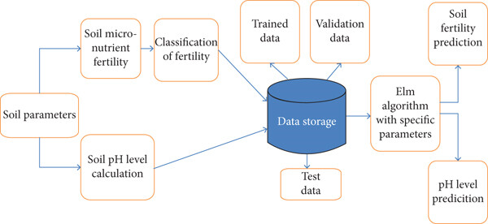**

**UML Diagrams:**

**CLASS DIAGRAM:**

The class diagram is used to refine the use case diagram and define a detailed design of the system. The class diagram classifies the actors defined in the use case diagram into a set of interrelated classes. The relationship or association between the classes can be either an "is-a" or "has-a" relationship. Each class in the class diagram may be capable of providing certain functionalities. These functionalities provided by the class are termed "methods" of the class. Apart from this, each class may have certain "attributes" that uniquely.



**Use case Diagram:**

A use case diagram in the Unified Modeling Language (UML) is a type of behavioral diagram defined by and created from a Use-case analysis. Its purpose is to present a graphical overview of the functionality provided by a system in terms of actors, their goals (represented as use cases), and any dependencies between those use cases. The main purpose of a use case diagram is to show what system functions are performed for which actor. Roles of the actors in the system can be depicted.



**Sequence Diagram:**

A sequence diagram represents the interaction between different objects in the system. The important aspect of a sequence diagram is that it is time-ordered. This means that the exact sequence of the interactions between the objects is represented step by step. Different objects in the sequence diagram interact with each other by passing "messages".



**Collaborative Diagram:**

A collaboration diagram groups together the interactions between different objects. The interactions are listed as numbered interactions that help to trace the sequence of the interactions. The collaboration diagram helps to identify all the possible interactions that each object has with other objects.



**Activity Diagram:**

An activity diagram, a type of UML diagram, visually represents the flow of control or activities within a system or process, utilizing standardized symbols such as rectangles for activities, diamonds for decision points, and arrows for transitions. It is extensively used in business process modeling to depict workflows and in software engineering to illustrate algorithmic logic or system behavior. Activity diagrams consist of activities representing actions or steps, transitions indicating the flow between activities, decision points for branching based on conditions, and start and end nodes marking the beginning and conclusion of the process. They offer clarity in understanding and communicating complex processes, aiding in analysis, optimization, and documentation, thus serving as essential tools for both business and software development contexts.

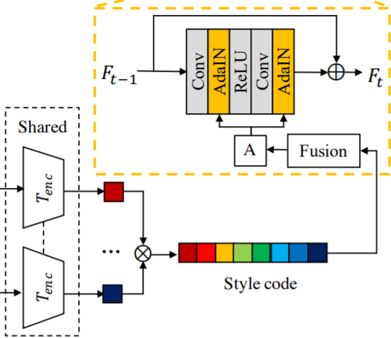

**Data Flow Diagram:**

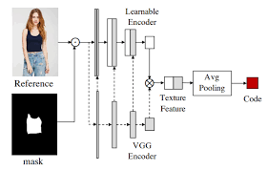

**Flow Chart Diagram:**

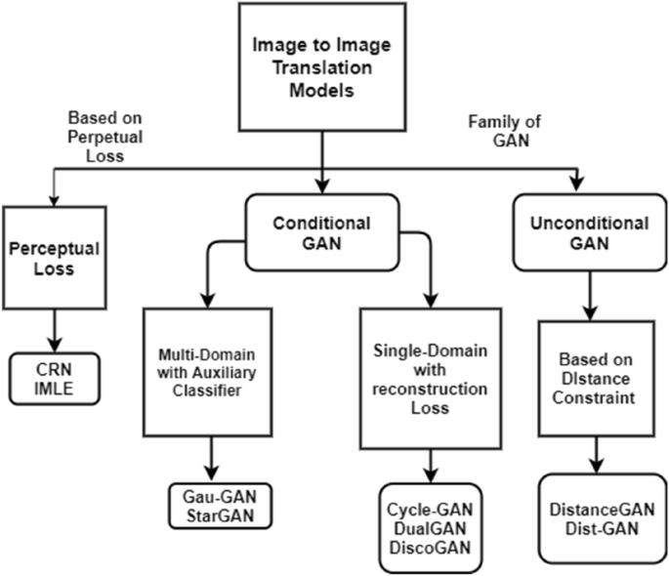

**SYSTEM STUDY**

**FEASIBILITY STUDY**

The feasibility of the project is analyzed in this phase and business proposal is put forth with a very general plan for the project and some cost estimates. During system analysis the feasibility study of the proposed system is to be carried out. This is to ensure that the proposed system is not a burden to the company. For feasibility analysis, some understanding of the major requirements for the system is essential.

Three key considerations involved in the feasibility analysis are

* ECONOMICAL FEASIBILITY
* TECHNICAL FEASIBILITY
* SOCIAL FEASIBILITY

**ECONOMICAL FEASIBILITY**

This study is carried out to check the economic impact that the system will have on the organization. The amount of fund that the company can pour into the research and development of the system is limited. The expenditures must be justified. Thus the developed system as well within the budget and this was achieved because most of the technologies used are freely available. Only the customized products had to be purchased.

### TECHNICAL FEASIBILITY

This study is carried out to check the technical feasibility, that is, the technical requirements of the system. Any system developed must not have a high demand on the available technical resources. This will lead to high demands on the available technical resources. This will lead to high demands being placed on the client. The developed system must have a modest requirement, as only minimal or null changes are required for implementing this system.

**SOCIAL FEASIBILITY**

The aspect of study is to check the level of acceptance of the system by the user. This includes the process of training the user to use the system efficiently. The user must not feel threatened by the system, instead must accept it as a necessity. The level of acceptance by the users solely depends on the methods that are employed to educate the user about the system and to make him familiar with it. His level of confidence must be raised so that he is also able to make some constructive criticism, which is welcomed, as he is the final user of the system.

**INPUT AND OUTPUT DESIGN**

**INPUT DESIGN**

The input design is the link between the information system and the user. It comprises the developing specification and procedures for data preparation and those steps are necessary to put transaction data in to a usable form for processing can be achieved by inspecting the computer to read data from a written or printed document or it can occur by having people keying the data directly into the system. The design of input focuses on controlling the amount of input required, controlling the errors, avoiding delay, avoiding extra steps and keeping the process simple. The input is designed in such a way so that it provides security and ease of use with retaining the privacy. Input Design considered the following things:

* What data should be given as input?
* How the data should be arranged or coded?
* The dialog to guide the operating personnel in providing input.
* Methods for preparing input validations and steps to follow when error occur.

**OBJECTIVES**

1.Input Design is the process of converting a user-oriented description of the input into a computer-based system. This design is important to avoid errors in the data input process and show the correct direction to the management for getting correct information from the computerized system.

2. It is achieved by creating user-friendly screens for the data entry to handle large volume of data. The goal of designing input is to make data entry easier and to be free from errors. The data entry screen is designed in such a way that all the data manipulates can be performed. It also provides record viewing facilities.

3.When the data is entered it will check for its validity. Data can be entered with the help of screens. Appropriate messages are provided as when needed so that the user will not be in maize of instant. Thus the objective of input design is to create an input layout that is easy to follow

**OUTPUT DESIGN**

A quality output is one, which meets the requirements of the end user and presents the information clearly. In any system results of processing are communicated to the users and to other system through outputs. In output design it is determined how the information is to be displaced for immediate need and also the hard copy output. It is the most important and direct source information to the user. Efficient and intelligent output design improves the system’s relationship to help user decision-making.

1. Designing computer output should proceed in an organized, well thought out manner; the right output must be developed while ensuring that each output element is designed so that people will find the system can use easily and effectively. When analysis design computer output, they should Identify the specific output that is needed to meet the requirements.

2.Select methods for presenting information.

3.Create document, report, or other formats that contain information produced by the system.

The output form of an information system should accomplish one or more of the following objectives.

* Convey information about past activities, current status or projections of the
* Future.
* Signal important events, opportunities, problems, or warnings.
* Trigger an action.
* Confirm an action.

**System Implementations:**

1. **Data Preprocessing**: Prepare the textual data by removing noise, such as special characters, punctuation, and stopwords. Tokenize the text into sentences or paragraphs to facilitate sentiment analysis and summarization.
2. **Sentiment Analysis Model**: Implement or utilize pre-trained sentiment analysis models capable of accurately detecting the sentiment polarity (positive, negative, neutral) of each sentence or paragraph in the text. Consider employing advanced techniques such as deep learning-based models or transformer architectures for improved accuracy.
3. **Summarization Model**: Implement a text summarization model capable of generating concise summaries while incorporating sentiment information. Explore both extractive and abstractive summarization techniques, considering factors such as coherence, informativeness, and sentiment preservation.
4. **Integration**: Integrate the sentiment analysis module with the summarization module to leverage sentiment information during the summarization process. Design mechanisms to prioritize or adjust the inclusion of sentences based on their sentiment polarity to ensure that the generated summaries reflect the emotional context of the original text.
5. **Evaluation**: Evaluate the performance of the implemented system using standard metrics such as ROUGE (Recall-Oriented Understudy for Gisting Evaluation) for summarization quality and sentiment classification accuracy metrics for sentiment analysis. Conduct thorough evaluations using benchmark datasets to assess the effectiveness and robustness of the system.
6. **Optimization**: Optimize the system for efficiency and scalability by leveraging techniques such as parallel processing, caching, and model compression. Consider deploying the system on distributed computing frameworks or utilizing hardware accelerators (e.g., GPUs) to improve processing speed and resource utilization.
7. **User Interface**: Develop a user-friendly interface for interacting with the system, allowing users to input text and view the generated summaries along with sentiment analysis results. Design the interface to be intuitive, responsive, and accessible across different devices and platforms.
8. **Deployment**: Deploy the implemented system in production environments, considering factors such as scalability, reliability, and security. Ensure proper monitoring and maintenance procedures are in place to address potential issues and ensure continuous performance optimization.
9. **Feedback Loop**: Establish a feedback loop to gather user feedback and monitor system performance over time. Use feedback to iteratively improve the system's accuracy, usability, and effectiveness based on user requirements and evolving needs.

**System Environment:**

# What is Python :-

Below are some facts about Python.

Python is currently the most widely used multi-purpose, high-level programming language.

Python allows programming in Object-Oriented and Procedural paradigms. Python programs generally are smaller than other programming languages like Java.

Programmers have to type relatively less and indentation requirement of the language, makes them readable all the time.

Python language is being used by almost all tech-giant companies like – Google, Amazon, Facebook, Instagram, Dropbox, Uber… etc.

The biggest strength of Python is huge collection of standard library which can be used for the following .

* + [Machine Learning](https://www.geeksforgeeks.org/machine-learning/)
  + GUI Applications (like Kivy, Tkinter, PyQt etc. )
  + Web frameworks like Django (used by YouTube, Instagram, Dropbox)
  + Image processing (like Opencv, Pillow)
  + Web scraping (like Scrapy, BeautifulSoup, Selenium)
  + Test frameworks
  + Multimedia

### Advantages of Python :-

Let’s see how Python dominates over other languages.

#### 1. Extensive Libraries

Python downloads with an extensive library and it contain code for various purposes like regular expressions, documentation-generation, unit-testing, web browsers, threading, databases, CGI, email, image manipulation, and more. So, we don’t have to write the complete code for that manually.

#### 2. Extensible

As we have seen earlier, Python can be**extended to other languages**. You can write some of your code in languages like C++ or C. This comes in handy, especially in projects.

#### 3. Embeddable

Complimentary to extensibility, Python is embeddable as well. You can put your Python code in your source code of a different language, like C++. This lets us add **scripting capabilities**to our code in the other language.

#### 4. Improved Productivity

The language’s simplicity and extensive libraries render programmers**more productive** than languages like Java and C++ do. Also, the fact that you need to write less and get more things done.

#### 5. IOT Opportunities

Since Python forms the basis of new platforms like Raspberry Pi, it finds the future bright for the Internet Of Things. This is a way to connect the language with the real world.

#### 6. Simple and Easy

When working with Java, you may have to create a class to print **‘Hello World’**. But in Python, just a print statement will do. It is also quite **easy to learn, understand,** and**code.** This is why when people pick up Python, they have a hard time adjusting to other more verbose languages like Java.

#### 7. Readable

Because it is not such a verbose language, reading Python is much like reading English. This is the reason why it is so easy to learn, understand, and code. It also does not need curly braces to define blocks, and **indentation is mandatory.** This further aids the readability of the code.

#### 8. Object-Oriented

This language supports both the **procedural and object-oriented**programming paradigms. While functions help us with code reusability, classes and objects let us model the real world. A class allows the **encapsulation of data** and functions into one.

#### 9. Free and Open-Source

Like we said earlier, Python is **freely available.** But not only can you[**download Python**](https://data-flair.training/blogs/install-python-windows/) for free, but you can also download its source code, make changes to it, and even distribute it. It downloads with an extensive collection of libraries to help you with your tasks.

#### 10. Portable

When you code your project in a language like C++, you may need to make some changes to it if you want to run it on another platform. But it isn’t the same with Python. Here, you need to**code only once**, and you can run it anywhere. This is called **Write Once Run Anywhere (WORA)**. However, you need to be careful enough not to include any system-dependent features.

#### 11. Interpreted

Lastly, we will say that it is an interpreted language. Since statements are executed one by one, **debugging is easier** than in compiled languages.

Any doubts till now in the advantages of Python? Mention in the comment section.

### Advantages of Python Over Other Languages

#### 1. Less Coding

Almost all of the tasks done in Python requires less coding when the same task is done in other languages. Python also has an awesome standard library support, so you don’t have to search for any third-party libraries to get your job done. This is the reason that many people suggest learning Python to beginners.

#### 2. Affordable

Python is free therefore individuals, small companies or big organizations can leverage the free available resources to build applications. Python is popular and widely used so it gives you better community support.

**The 2019 Github annual survey showed us that Python has overtaken Java in the most popular programming language category.**

#### 3. Python is for Everyone

Python code can run on any machine whether it is Linux, Mac or Windows. Programmers need to learn different languages for different jobs but with Python, you can professionally build web apps, perform data analysis and [**machine learning**](https://data-flair.training/blogs/machine-learning-tutorials-home/), automate things, do web scraping and also build games and powerful visualizations. It is an all-rounder programming language.

### Disadvantages of Python

So far, we’ve seen why Python is a great choice for your project. But if you choose it, you should be aware of its consequences as well. Let’s now see the downsides of choosing Python over another language.

#### 1. Speed Limitations

We have seen that Python code is executed line by line. But since [Python](https://www.python.org/) is interpreted, it often results in **slow execution**. This, however, isn’t a problem unless speed is a focal point for the project. In other words, unless high speed is a requirement, the benefits offered by Python are enough to distract us from its speed limitations.

#### 2. Weak in Mobile Computing and Browsers

While it serves as an excellent server-side language, Python is much rarely seen on the **client-side**. Besides that, it is rarely ever used to implement smartphone-based applications. One such application is called **Carbonnelle**.

The reason it is not so famous despite the existence of Brython is that it isn’t that secure.

#### 3. Design Restrictions

As you know, Python is **dynamically-typed**. This means that you don’t need to declare the type of variable while writing the code. It uses **duck-typing**. But wait, what’s that? Well, it just means that if it looks like a duck, it must be a duck. While this is easy on the programmers during coding, it can**raise run-time errors**.

#### 4. Underdeveloped Database Access Layers

Compared to more widely used technologies like **JDBC (Java DataBase Connectivity)** and **ODBC (Open DataBase Connectivity)**, Python’s database access layers are a bit underdeveloped. Consequently, it is less often applied in huge enterprises.

#### 5. Simple

No, we’re not kidding. Python’s simplicity can indeed be a problem. Take my example. I don’t do Java, I’m more of a Python person. To me, its syntax is so simple that the verbosity of Java code seems unnecessary.

This was all about the Advantages and Disadvantages of Python Programming Language.

**History of Python : -**

What do the alphabet and the programming language Python have in common? Right, both start with ABC. If we are talking about ABC in the Python context, it's clear that the programming language ABC is meant. ABC is a general-purpose programming language and programming environment, which had been developed in the Netherlands, Amsterdam, at the CWI (Centrum Wiskunde &Informatica). The greatest achievement of ABC was to influence the design of Python.Python was conceptualized in the late 1980s. Guido van Rossum worked that time in a project at the CWI, called Amoeba, a distributed operating system. In an interview with Bill Venners1, Guido van Rossum said: "In the early 1980s, I worked as an implementer on a team building a language called ABC at Centrum voor Wiskunde en Informatica (CWI).

I don't know how well people know ABC's influence on Python. I try to mention ABC's influence because I'm indebted to everything I learned during that project and to the people who worked on it."Later on in the same Interview, Guido van Rossum continued: "I remembered all my experience and some of my frustration with ABC. I decided to try to design a simple scripting language that possessed some of ABC's better properties, but without its problems. So I started typing. I created a simple virtual machine, a simple parser, and a simple runtime. I made my own version of the various ABC parts that I liked. I created a basic syntax, used indentation for statement grouping instead of curly braces or begin-end blocks, and developed a small number of powerful data types: a hash table (or dictionary, as we call it), a list, strings, and numbers."

**What is Machine Learning : -**

Before we take a look at the details of various machine learning methods, let's start by looking at what machine learning is, and what it isn't. Machine learning is often categorized as a subfield of artificial intelligence, but I find that categorization can often be misleading at first brush. The study of machine learning certainly arose from research in this context, but in the data science application of machine learning methods, it's more helpful to think of machine learning as a means of building models of data.

Fundamentally, machine learning involves building mathematical models to help understand data. "Learning" enters the fray when we give these models tunable parameters that can be adapted to observed data; in this way the program can be considered to be "learning" from the data.

Once these models have been fit to previously seen data, they can be used to predict and understand aspects of newly observed data. I'll leave to the reader the more philosophical digression regarding the extent to which this type of mathematical, model-based "learning" is similar to the "learning" exhibited by the human brain.Understanding the problem setting in machine learning is essential to using these tools effectively, and so we will start with some broad categorizations of the types of approaches we'll discuss here.

**Categories Of Machine Leaning :-**

At the most fundamental level, machine learning can be categorized into two main types: supervised learning and unsupervised learning.

Supervised learning involves somehow modeling the relationship between measured features of data and some label associated with the data; once this model is determined, it can be used to apply labels to new, unknown data. This is further subdivided into classification tasks and regression tasks: in classification, the labels are discrete categories, while in regression, the labels are continuous quantities. We will see examples of both types of supervised learning in the following section.

Unsupervised learning involves modeling the features of a dataset without reference to any label, and is often described as "letting the dataset speak for itself." These models include tasks such as clustering and dimensionality reduction.

Clustering algorithms identify distinct groups of data, while dimensionality reduction algorithms search for more succinct representations of the data. We will see examples of both types of unsupervised learning in the following section.

## Need for Machine Learning

Human beings, at this moment, are the most intelligent and advanced species on earth because they can think, evaluate and solve complex problems. On the other side, AI is still in its initial stage and haven’t surpassed human intelligence in many aspects. Then the question is that what is the need to make machine learn? The most suitable reason for doing this is, “to make decisions, based on data, with efficiency and scale”.

Lately, organizations are investing heavily in newer technologies like Artificial Intelligence, Machine Learning and Deep Learning to get the key information from data to perform several real-world tasks and solve problems. We can call it data-driven decisions taken by machines, particularly to automate the process. These data-driven decisions can be used, instead of using programing logic, in the problems that cannot be programmed inherently. The fact is that we can’t do without human intelligence, but other aspect is that we all need to solve real-world problems with efficiency at a huge scale. That is why the need for machine learning arises.

## Challenges in Machines Learning :-

While Machine Learning is rapidly evolving, making significant strides with cybersecurity and autonomous cars, this segment of AI as whole still has a long way to go. The reason behind is that ML has not been able to overcome number of challenges. The challenges that ML is facing currently are −

**Quality of data** − Having good-quality data for ML algorithms is one of the biggest challenges. Use of low-quality data leads to the problems related to data preprocessing and feature extraction.

**Time-Consuming task** − Another challenge faced by ML models is the consumption of time especially for data acquisition, feature extraction and retrieval.

**Lack of specialist persons** − As ML technology is still in its infancy stage, availability of expert resources is a tough job.

**No clear objective for formulating business problems** − Having no clear objective and well-defined goal for business problems is another key challenge for ML because this technology is not that mature yet.

**Issue of overfitting & underfitting** − If the model is overfitting or underfitting, it cannot be represented well for the problem.

**Curse of dimensionality** − Another challenge ML model faces is too many features of data points. This can be a real hindrance.

**Difficulty in deployment** − Complexity of the ML model makes it quite difficult to be deployed in real life.

## Applications of Machines Learning :-

Machine Learning is the most rapidly growing technology and according to researchers we are in the golden year of AI and ML. It is used to solve many real-world complex problems which cannot be solved with traditional approach. Following are some real-world applications of ML −

* Emotion analysis
* Sentiment analysis
* Error detection and prevention
* Weather forecasting and prediction
* Stock market analysis and forecasting
* Speech synthesis
* Speech recognition
* Customer segmentation
* Object recognition
* Fraud detection
* Fraud prevention
* Recommendation of products to customer in online shopping

# How to Start Learning Machine Learning?

Arthur Samuel coined the term **“Machine Learning”** in 1959 and defined it as a **“Field of study that gives computers the capability to learn without being explicitly programmed”.**

And that was the beginning of Machine Learning! In modern times, Machine Learning is one of the most popular (if not the most!) career choices. According to [Indeed](http://blog.indeed.com/2019/03/14/best-jobs-2019/), Machine Learning Engineer Is The Best Job of 2019 with a 344% growth and an average base salary of **$146,085** per year.

But there is still a lot of doubt about what exactly is Machine Learning and how to start learning it? So this article deals with the Basics of Machine Learning and also the path you can follow to eventually become a full-fledged Machine Learning Engineer. Now let’s get started!!!

### How to start learning ML?

This is a rough roadmap you can follow on your way to becoming an insanely talented Machine Learning Engineer. Of course, you can always modify the steps according to your needs to reach your desired end-goal!

### Step 1 – Understand the Prerequisites

In case you are a genius, you could start ML directly but normally, there are some prerequisites that you need to know which include Linear Algebra, Multivariate Calculus, Statistics, and Python. And if you don’t know these, never fear! You don’t need a Ph.D. degree in these topics to get started but you do need a basic understanding.

#### (a) Learn Linear Algebra and Multivariate Calculus

Both Linear Algebra and Multivariate Calculus are important in Machine Learning. However, the extent to which you need them depends on your role as a data scientist. If you are more focused on application heavy machine learning, then you will not be that heavily focused on maths as there are many common libraries available. But if you want to focus on R&D in Machine Learning, then mastery of Linear Algebra and Multivariate Calculus is very important as you will have to implement many ML algorithms from scratch.

#### (b) Learn Statistics

Data plays a huge role in Machine Learning. In fact, around 80% of your time as an ML expert will be spent collecting and cleaning data. And statistics is a field that handles the collection, analysis, and presentation of data. So it is no surprise that you need to learn it!!!  
Some of the key concepts in statistics that are important are Statistical Significance, Probability Distributions, Hypothesis Testing, Regression, etc. Also, Bayesian Thinking is also a very important part of ML which deals with various concepts like Conditional Probability, Priors, and Posteriors, Maximum Likelihood, etc.

#### (c) Learn Python

Some people prefer to skip Linear Algebra, Multivariate Calculus and Statistics and learn them as they go along with trial and error. But the one thing that you absolutely cannot skip is [Python](https://www.geeksforgeeks.org/python-programming-language/)! While there are other languages you can use for Machine Learning like R, Scala, etc. Python is currently the most popular language for ML. In fact, there are many Python libraries that are specifically useful for Artificial Intelligence and Machine Learning such as [Keras](https://keras.io/" \t "_blank), [TensorFlow](https://www.tensorflow.org/" \t "_blank), [Scikit-learn](https://scikit-learn.org/stable/" \t "_blank), etc.

So if you want to learn ML, it’s best if you learn Python! You can do that using various online resources and courses such as [**Fork Python**](https://practice.geeksforgeeks.org/courses/fork-python) available Free on GeeksforGeeks.

### Step 2 – Learn Various ML Concepts

Now that you are done with the prerequisites, you can move on to actually learning ML (Which is the fun part!!!) It’s best to start with the basics and then move on to the more complicated stuff. Some of the basic concepts in ML are:

#### (a) Terminologies of Machine Learning

* **Model –**A model is a specific representation learned from data by applying some machine learning algorithm. A model is also called a hypothesis.
* **Feature –**A feature is an individual measurable property of the data. A set of numeric features can be conveniently described by a feature vector. Feature vectors are fed as input to the model. For example, in order to predict a fruit, there may be features like color, smell, taste, etc.
* **Target (Label) –**A target variable or label is the value to be predicted by our model. For the fruit example discussed in the feature section, the label with each set of input would be the name of the fruit like apple, orange, banana, etc.
* **Training –**The idea is to give a set of inputs(features) and it’s expected outputs(labels), so after training, we will have a model (hypothesis) that will then map new data to one of the categories trained on.
* **Prediction –**Once our model is ready, it can be fed a set of inputs to which it will provide a predicted output(label).

#### (b) Types of Machine Learning

* **Supervised Learning –**This involves learning from a training dataset with labeled data using classification and regression models. This learning process continues until the required level of performance is achieved.
* **Unsupervised Learning –**This involves using unlabelled data and then finding the underlying structure in the data in order to learn more and more about the data itself using factor and cluster analysis models.
* **Semi-supervised Learning –**This involves using unlabelled data like Unsupervised Learning with a small amount of labeled data. Using labeled data vastly increases the learning accuracy and is also more cost-effective than Supervised Learning.
* **Reinforcement Learning –**This involves learning optimal actions through trial and error. So the next action is decided by learning behaviors that are based on the current state and that will maximize the reward in the future.

### Advantages of Machine learning :-

#### 1. Easily identifies trends and patterns -

Machine Learning can review large volumes of data and discover specific trends and patterns that would not be apparent to humans. For instance, for an e-commerce website like Amazon, it serves to understand the browsing behaviors and purchase histories of its users to help cater to the right products, deals, and reminders relevant to them. It uses the results to reveal relevant advertisements to them.

#### 2. No human intervention needed (automation)

With ML, you don’t need to babysit your project every step of the way. Since it means giving machines the ability to learn, it lets them make predictions and also improve the algorithms on their own. A common example of this is anti-virus softwares; they learn to filter new threats as they are recognized. ML is also good at recognizing spam.

#### 3. Continuous Improvement

As [**ML algorithms**](https://data-flair.training/blogs/machine-learning-algorithms/) gain experience, they keep improving in accuracy and efficiency. This lets them make better decisions. Say you need to make a weather forecast model. As the amount of data you have keeps growing, your algorithms learn to make more accurate predictions faster.

#### 4. Handling multi-dimensional and multi-variety data

Machine Learning algorithms are good at handling data that are multi-dimensional and multi-variety, and they can do this in dynamic or uncertain environments.

#### 5. Wide Applications

You could be an e-tailer or a healthcare provider and make ML work for you. Where it does apply, it holds the capability to help deliver a much more personal experience to customers while also targeting the right customers.

### Disadvantages of Machine Learning :-

#### 1. Data Acquisition

Machine Learning requires massive data sets to train on, and these should be inclusive/unbiased, and of good quality. There can also be times where they must wait for new data to be generated.

#### 2. Time and Resources

ML needs enough time to let the algorithms learn and develop enough to fulfill their purpose with a considerable amount of accuracy and relevancy. It also needs massive resources to function. This can mean additional requirements of computer power for you.

#### 3. Interpretation of Results

Another major challenge is the ability to accurately interpret results generated by the algorithms. You must also carefully choose the algorithms for your purpose.

#### 4. High error-susceptibility

[Machine Learning](https://en.wikipedia.org/wiki/Machine_learning) is autonomous but highly susceptible to errors. Suppose you train an algorithm with data sets small enough to not be inclusive. You end up with biased predictions coming from a biased training set. This leads to irrelevant advertisements being displayed to customers. In the case of ML, such blunders can set off a chain of errors that can go undetected for long periods of time. And when they do get noticed, it takes quite some time to recognize the source of the issue, and even longer to correct it.

**Python Development Steps : -**

Guido Van Rossum published the first version of Python code (version 0.9.0) at alt.sources in February 1991. This release included already exception handling, functions, and the core data types of list, dict, str and others. It was also object oriented and had a module system.  
Python version 1.0 was released in January 1994. The major new features included in this release were the functional programming tools lambda, map, filter and reduce, which Guido Van Rossum never liked.Six and a half years later in October 2000, Python 2.0 was introduced. This release included list comprehensions, a full garbage collector and it was supporting unicode.Python flourished for another 8 years in the versions 2.x before the next major release as Python 3.0 (also known as "Python 3000" and "Py3K") was released. Python 3 is not backwards compatible with Python 2.x.

The emphasis in Python 3 had been on the removal of duplicate programming constructs and modules, thus fulfilling or coming close to fulfilling the 13th law of the Zen of Python: "There should be one -- and preferably only one -- obvious way to do it."Some changes in Python 7.3:

* Print is now a function
* Views and iterators instead of lists
* The rules for ordering comparisons have been simplified. E.g. a heterogeneous list cannot be sorted, because all the elements of a list must be comparable to each other.
* There is only one integer type left, i.e. int. long is int as well.
* The division of two integers returns a float instead of an integer. "//" can be used to have the "old" behaviour.
* Text Vs. Data Instead Of Unicode Vs. 8-bit

**Purpose :-**

We demonstrated that our approach enables successful segmentation of intra-retinal layers—even with low-quality images containing speckle noise, low contrast, and different intensity ranges throughout—with the assistance of the ANIS feature.

**Python**

Python is an interpreted high-level programming language for general-purpose programming. Created by Guido van Rossum and first released in 1991, Python has a design philosophy that emphasizes code readability, notably using significant whitespace.

Python features a dynamic type system and automatic memory management. It supports multiple programming paradigms, including object-oriented, imperative, functional and procedural, and has a large and comprehensive standard library.

* Python is Interpreted − Python is processed at runtime by the interpreter. You do not need to compile your program before executing it. This is similar to PERL and PHP.
* Python is Interactive − you can actually sit at a Python prompt and interact with the interpreter directly to write your programs.

Python also acknowledges that speed of development is important. Readable and terse code is part of this, and so is access to powerful constructs that avoid tedious repetition of code. Maintainability also ties into this may be an all but useless metric, but it does say something about how much code you have to scan, read and/or understand to troubleshoot problems or tweak behaviors. This speed of development, the ease with which a programmer of other languages can pick up basic Python skills and the huge standard library is key to another area where Python excels. All its tools have been quick to implement, saved a lot of time, and several of them have later been patched and updated by people with no Python background - without breaking.

**Modules Used in Project :-**

**Tensorflow**

TensorFlow is a [free](https://en.wikipedia.org/wiki/Free_software) and [open-source](https://en.wikipedia.org/wiki/Open-source_software) [software library for dataflow and differentiable programming](https://en.wikipedia.org/wiki/Library_(computing)) across a range of tasks. It is a symbolic math library, and is also used for [machine learning](https://en.wikipedia.org/wiki/Machine_learning) applications such as [neural networks](https://en.wikipedia.org/wiki/Neural_networks). It is used for both research and production at [Google](https://en.wikipedia.org/wiki/Google).‍

TensorFlow was developed by the [Google Brain](https://en.wikipedia.org/wiki/Google_Brain) team for internal Google use. It was released under the [Apache 2.0](https://en.wikipedia.org/wiki/Apache_License) [open-source license](https://en.wikipedia.org/wiki/Open-source_license) on November 9, 2015.

**Numpy**

Numpy is a general-purpose array-processing package. It provides a high-performance multidimensional array object, and tools for working with these arrays.

It is the fundamental package for scientific computing with Python. It contains various features including these important ones:

* A powerful N-dimensional array object
* Sophisticated (broadcasting) functions
* Tools for integrating C/C++ and Fortran code
* Useful linear algebra, Fourier transform, and random number capabilities

Besides its obvious scientific uses, Numpy can also be used as an efficient multi-dimensional container of generic data. Arbitrary data-types can be defined using Numpy which allows Numpy to seamlessly and speedily integrate with a wide variety of databases.

**Pandas**

Pandas is an open-source Python Library providing high-performance data manipulation and analysis tool using its powerful data structures. Python was majorly used for data munging and preparation. It had very little contribution towards data analysis. Pandas solved this problem. Using Pandas, we can accomplish five typical steps in the processing and analysis of data, regardless of the origin of data load, prepare, manipulate, model, and analyze. Python with Pandas is used in a wide range of fields including academic and commercial domains including finance, economics, Statistics, analytics, etc.

**Matplotlib**

Matplotlib is a Python 2D plotting library which produces publication quality figures in a variety of hardcopy formats and interactive environments across platforms. Matplotlib can be used in Python scripts, the Python and [IPython](http://ipython.org/) shells, the [Jupyter](http://jupyter.org/) Notebook, web application servers, and four graphical user interface toolkits. Matplotlib tries to make easy things easy and hard things possible. You can generate plots, histograms, power spectra, bar charts, error charts, scatter plots, etc., with just a few lines of code. For examples, see the [sample plots](https://matplotlib.org/tutorials/introductory/sample_plots.html) and [thumbnail gallery](https://matplotlib.org/gallery/index.html).

For simple plotting the pyplot module provides a MATLAB-like interface, particularly when combined with IPython. For the power user, you have full control of line styles, font properties, axes properties, etc, via an object oriented interface or via a set of functions familiar to MATLAB users.

**Scikit – learn**

Scikit-learn provides a range of supervised and unsupervised learning algorithms via a consistent interface in Python. It is licensed under a permissive simplified BSD license and is distributed under many Linux distributions, encouraging academic and commercial use. **Python**

Python is an interpreted high-level programming language for general-purpose programming. Created by Guido van Rossum and first released in 1991, Python has a design philosophy that emphasizes code readability, notably using significant whitespace.

Python features a dynamic type system and automatic memory management. It supports multiple programming paradigms, including object-oriented, imperative, functional and procedural, and has a large and comprehensive standard library.

* Python is Interpreted − Python is processed at runtime by the interpreter. You do not need to compile your program before executing it. This is similar to PERL and PHP.
* Python is Interactive − you can actually sit at a Python prompt and interact with the interpreter directly to write your programs.

Python also acknowledges that speed of development is important. Readable and terse code is part of this, and so is access to powerful constructs that avoid tedious repetition of code. Maintainability also ties into this may be an all but useless metric, but it does say something about how much code you have to scan, read and/or understand to troubleshoot problems or tweak behaviors. This speed of development, the ease with which a programmer of other languages can pick up basic Python skills and the huge standard library is key to another area where Python excels.

All its tools have been quick to implement, saved a lot of time, and several of them have later been patched and updated by people with no Python background - without breaking.

**Install Python Step-by-Step in Windows and Mac :**

Python a versatile programming language doesn’t come pre-installed on your computer devices. Python was first released in the year 1991 and until today it is a very popular high-level programming language. Its style philosophy emphasizes code readability with its notable use of great whitespace.

The object-oriented approach and language construct provided by Python enables programmers to write both clear and logical code for projects. This software does not come pre-packaged with Windows.

## How to Install Python on Windows and Mac :

There have been several updates in the Python version over the years. The question is how to install Python? It might be confusing for the beginner who is willing to start learning Python but this tutorial will solve your query. The latest or the newest version of Python is version 3.7.4 or in other words, it is Python 3.

**Note:** The python version 3.7.4 cannot be used on Windows XP or earlier devices.

Before you start with the installation process of Python. First, you need to know about your **System Requirements**. Based on your system type i.e. operating system and based processor, you must download the python version. My system type is a **Windows 64-bit operating system**. So the steps below are to install python version 3.7.4 on Windows 7 device or to install Python 3. [Download the Python Cheatsheet here.](https://myelearninghub.com/python-cheat-sheet/)The steps on how to install Python on Windows 10, 8 and 7 are **divided into 4 parts** to help understand better.

### Download the Correct version into the system

**Step 1:** Go to the official site to download and install python using Google Chrome or any other web browser. OR Click on the following link: [https://www.python.org](https://www.python.org/)



Now, check for the latest and the correct version for your operating system.

**Step 2:** Click on the Download Tab.

****

**Step 3:** You can either select the Download Python for windows 3.7.4 button in Yellow Color or you can scroll further down and click on download with respective to their version. Here, we are downloading the most recent python version for windows 3.7.4

****

**Step 4:** Scroll down the page until you find the Files option.

**Step 5:** Here you see a different version of python along with the operating system.



• To download Windows 32-bit python, you can select any one from the three options: Windows x86 embeddable zip file, Windows x86 executable installer or Windows x86 web-based installer.

•To download Windows 64-bit python, you can select any one from the three options: Windows x86-64 embeddable zip file, Windows x86-64 executable installer or Windows x86-64 web-based installer.

Here we will install Windows x86-64 web-based installer. Here your first part regarding which version of python is to be downloaded is completed. Now we move ahead with the second part in installing python i.e. Installation

**Note:** To know the changes or updates that are made in the version you can click on the Release Note Option.

### Installation of Python

**Step 1:** Go to Download and Open the downloaded python version to carry out the installation process.



**Step 2:** Before you click on Install Now, Make sure to put a tick on Add Python 3.7 to PATH.



**Step 3:** Click on Install NOW After the installation is successful. Click on Close.



With these above three steps on python installation, you have successfully and correctly installed Python. Now is the time to verify the installation.

**Note:** The installation process might take a couple of minutes.

### Verify the Python Installation

**Step 1:** Click on Start

**Step 2:** In the Windows Run Command, type “cmd”.



**Step 3:** Open the Command prompt option.

**Step 4:** Let us test whether the python is correctly installed. Type **python –V** and press Enter.



**Step 5:** You will get the answer as 3.7.4

**Note:** If you have any of the earlier versions of Python already installed. You must first uninstall the earlier version and then install the new one.

### Check how the Python IDLE works

**Step 1:** Click on Start

**Step 2:** In the Windows Run command, type “python idle”.



**Step 3:** Click on IDLE (Python 3.7 64-bit) and launch the program

**Step 4:** To go ahead with working in IDLE you must first save the file. **Click on File > Click on Save**



**Step 5:** Name the file and save as type should be Python files. Click on SAVE. Here I have named the files as Hey World.

**Step 6:** Now for e.g. **enter print**

**SYSTEM TEST**

The purpose of testing is to discover errors. Testing is the process of trying to discover every conceivable fault or weakness in a work product. It provides a way to check the functionality of components, sub assemblies, assemblies and/or a finished product It is the process of exercising software with the intent of ensuring that the Software system meets its requirements and user expectations and does not fail in an unacceptable manner. There are various types of test. Each test type addresses a specific testing requirement.

### TYPES OF TESTS

**Unit testing**

Unit testing involves the design of test cases that validate that the internal program logic is functioning properly, and that program inputs produce valid outputs. All decision branches and internal code flow should be validated. It is the testing of individual software units of the application .it is done after the completion of an individual unit before integration. This is a structural testing, that relies on knowledge of its construction and is invasive. Unit tests perform basic tests at component level and test a specific business process, application, and/or system configuration. Unit tests ensure that each unique path of a business process performs accurately to the documented specifications and contains clearly defined inputs and expected results.

**Integration testing**

Integration tests are designed to test integrated software components to determine if they actually run as one program. Testing is event driven and is more concerned with the basic outcome of screens or fields. Integration tests demonstrate that although the components were individually satisfaction, as shown by successfully unit testing, the combination of components is correct and consistent. Integration testing is specifically aimed at exposing the problems that arise from the combination of components.

**Functional test**

Functional tests provide systematic demonstrations that functions tested are available as specified by the business and technical requirements, system documentation, and user manuals.

Functional testing is centered on the following items:

Valid Input : identified classes of valid input must be accepted.

Invalid Input : identified classes of invalid input must be rejected.

Functions : identified functions must be exercised.

Output : identified classes of application outputs must be exercised.

Systems/Procedures : interfacing systems or procedures must be invoked.

Organization and preparation of functional tests is focused on requirements, key functions, or special test cases. In addition, systematic coverage pertaining to identify Business process flows; data fields, predefined processes, and successive processes must be considered for testing. Before functional testing is complete, additional tests are identified and the effective value of current tests is determined.

**System Test**

System testing ensures that the entire integrated software system meets requirements. It tests a configuration to ensure known and predictable results. An example of system testing is the configuration oriented system integration test. System testing is based on process descriptions and flows, emphasizing pre-driven process links and integration points.

**White Box Testing**

White Box Testing is a testing in which in which the software tester has knowledge of the inner workings, structure and language of the software, or at least its purpose. It is purpose. It is used to test areas that cannot be reached from a black box level.

**Black Box Testing**

Black Box Testing is testing the software without any knowledge of the inner workings, structure or language of the module being tested. Black box tests, as most other kinds of tests, must be written from a definitive source document, such as specification or requirements document, such as specification or requirements document. It is a testing in which the software under test is treated, as a black box .you cannot “see” into it. The test provides inputs and responds to outputs without considering how the software works.

**Unit Testing**

Unit testing is usually conducted as part of a combined code and unit test phase of the software lifecycle, although it is not uncommon for coding and unit testing to be conducted as two distinct phases.

**Test strategy and approach**

Field testing will be performed manually and functional tests will be written in detail.

**Test objectives**

* All field entries must work properly.
* Pages must be activated from the identified link.
* The entry screen, messages and responses must not be delayed.

**Features to be tested**

* Verify that the entries are of the correct format
* No duplicate entries should be allowed
* All links should take the user to the correct page.

# Integration Testing

Software integration testing is the incremental integration testing of two or more integrated software components on a single platform to produce failures caused by interface defects.

The task of the integration test is to check that components or software applications, e.g. components in a software system or – one step up – software applications at the company level – interact without error.

**Test Results:** All the test cases mentioned above passed successfully. No defects encountered.

**Acceptance Testing**

User Acceptance Testing is a critical phase of any project and requires significant participation by the end user. It also ensures that the system meets the functional requirements.

**Test Results:** All the test cases mentioned above passed successfully. No defects encountere

**Test cases1:**

**Test case for Login form:**

|  |  |
| --- | --- |
| **FUNCTION:** | **LOGIN** |
| **EXPECTED RESULTS:** | Should Validate the user and check his existence in database |
| **ACTUAL RESULTS:** | Validate the user and checking the user against the database |
| **LOW PRIORITY** | **No** |
| **HIGH PRIORITY** | **Yes** |

**Test case2:**

**Test case for User Registration form:**

|  |  |
| --- | --- |
| **FUNCTION:** | **USER REGISTRATION** |
| **EXPECTED RESULTS:** | Should check if all the fields are filled by the user and saving the user to database. |
| **ACTUAL RESULTS:** | Checking whether all the fields are field by user or not through validations and saving user. |
| **LOW PRIORITY** | **No** |
| **HIGH PRIORITY** | **Yes** |

**Test case3:**

**Test case for Change Password:**

When the old password does not match with the new password ,then this results in displaying an error message as “ OLD PASSWORD DOES NOT MATCH WITH THE NEW PASSWORD”.

|  |  |
| --- | --- |
| **FUNCTION:** | **Change Password** |
| **EXPECTED RESULTS:** | Should check if old password and new password fields are filled by the user and saving the user to database. |
| **ACTUAL RESULTS:** | Checking whether all the fields are field by user or not through validations and saving user. |
| **LOW PRIORITY** | **No** |
| **HIGH PRIORITY** | **Yes** |

**SCREEN SHOTS**

In this paper author employing deep learning based algorithm called Extreme Learning Model (ELM) to classify soil nutrients which helps in predicting crop growth. High nutrients make soil more fertile so using IOT sensor author collecting soil nutrients such as PH, potassium, nitrogen etc. This nutrients will get trained with ELM algorithm and this training model can be applied on new test data to predict soil as ‘Less Fertile, Medium and high fertile’.

To train above algorithm we have downloaded soil fertility dataset from below KAGGLE URL

<https://www.kaggle.com/datasets/rahuljaiswalonkaggle/soil-fertility-dataset>

author compare propose ELM performance with existing algorithm like SVM and each algorithm performance is evaluated in terms of accuracy, precision, recall and FSCORE.

To implement this project we have designed following modules

1. User Login: any user can login to system using username and password as ‘admin and admin’
2. Process dataset: after login user can load dataset and then perform dataset processing like removing missing values, shuffling and normalization and then split dataset into train and test where application using 80% dataset for training and 20% for testing
3. Existing SVM: using this module application will input 80% training data to SVM algorithm to train a model and this model will be applied on 20% test data to calculate prediction accuracy
4. Propose ELM: using this module application will input 80% training data to ELM algorithm to train a model and this model will be applied on 20% test data to calculate prediction accuracy
5. Comparison Graph: will plot comparison graph between both algorithms
6. Predict Fertility: using this module will plot test data and then ELM will predict soil fertility.

SCREEN SHOTS

To run project double click on run.bat file to get below screen

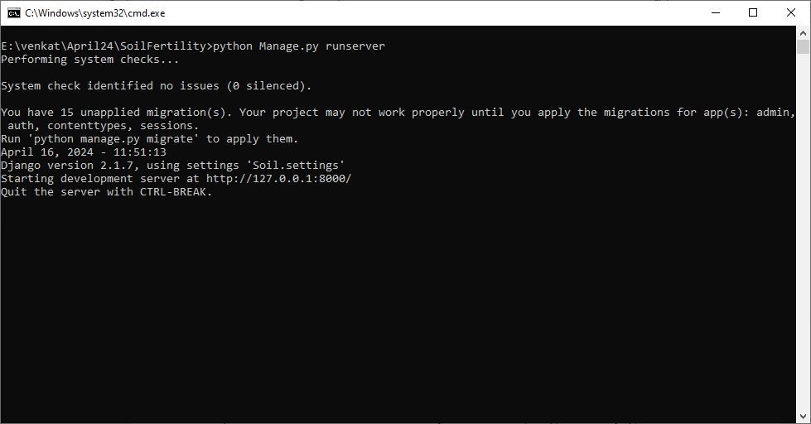

In above screen python server started and now open browser and enter URL as <http://127.0.0.1:8000/index.html> and press enter key to get below page

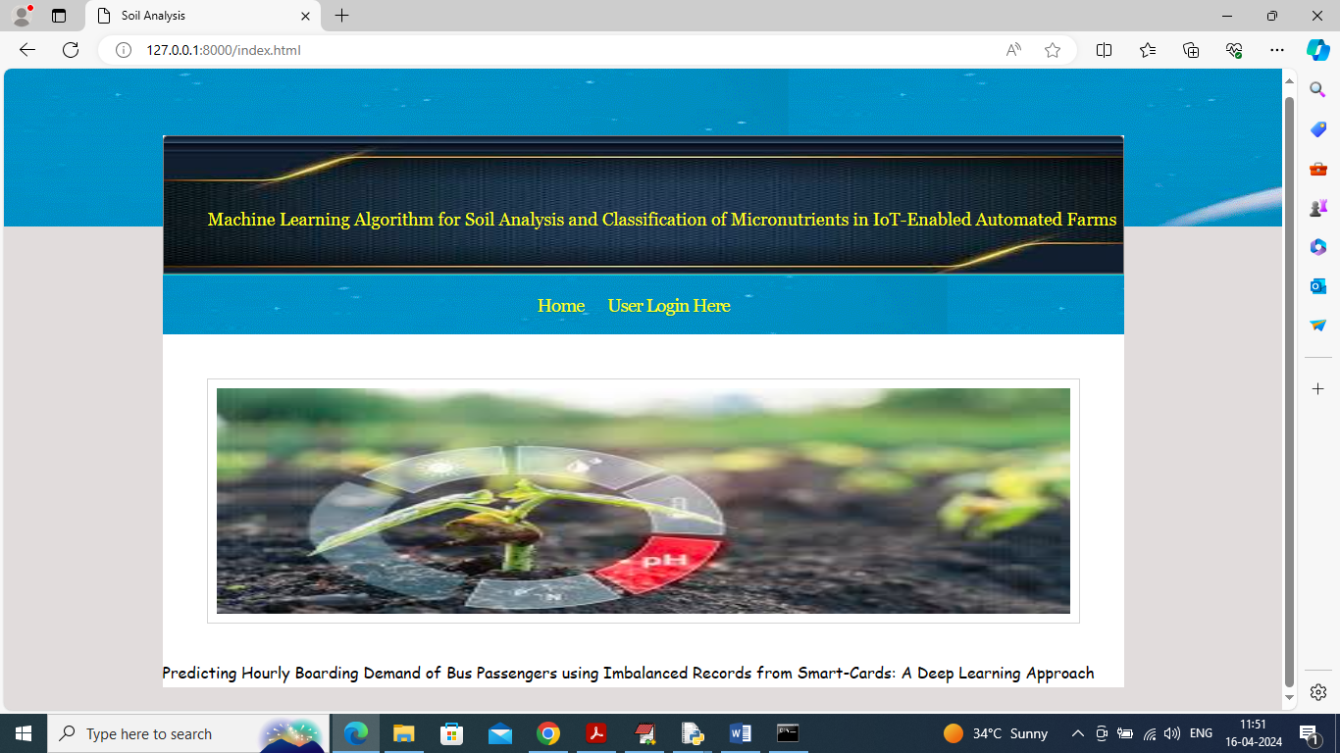

In above screen click on ‘User Login’ link to get below page

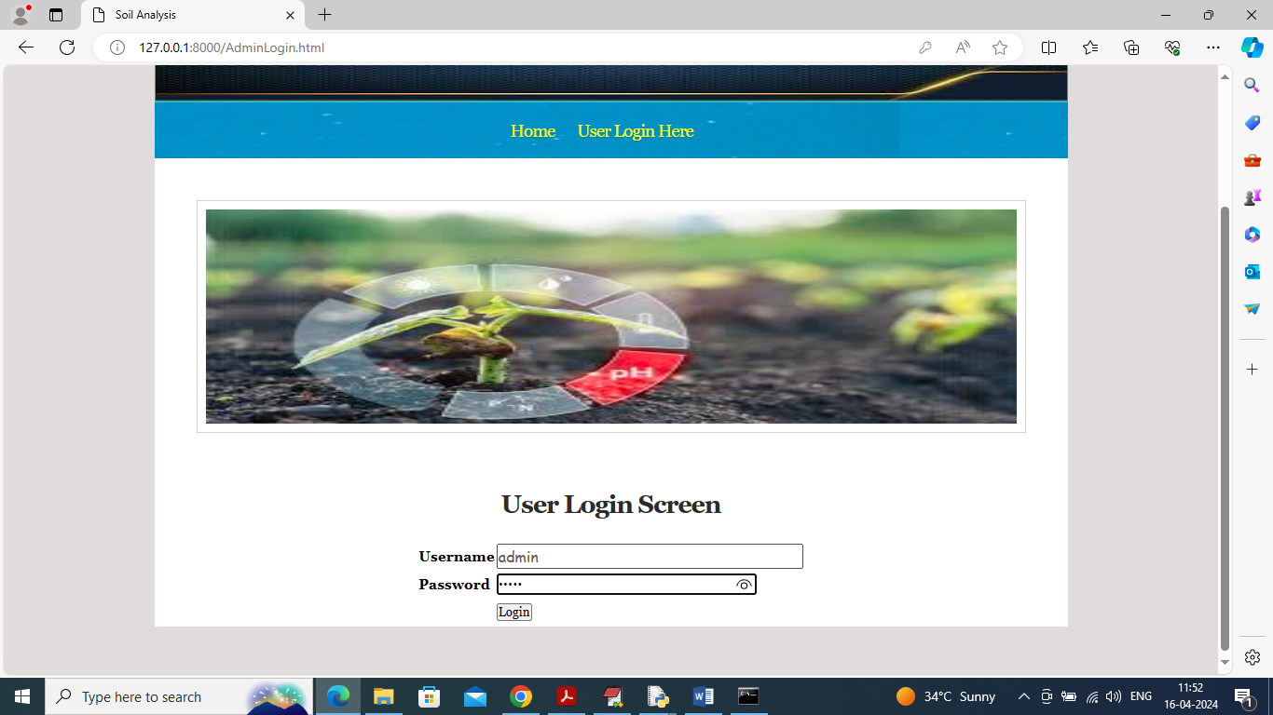

In above screen user is login and after login will get below page

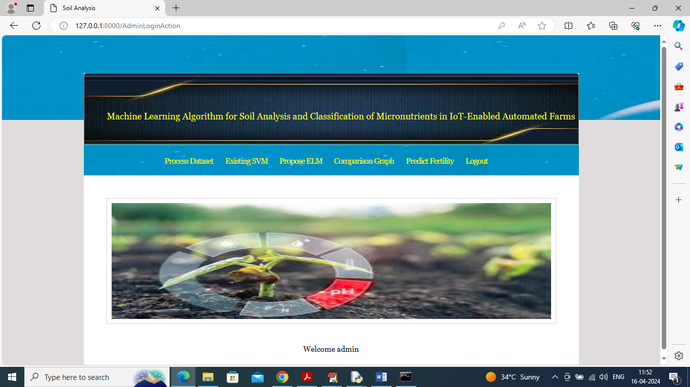

In above screen user can click on ‘Process Dataset’ link to load and process dataset and get below page

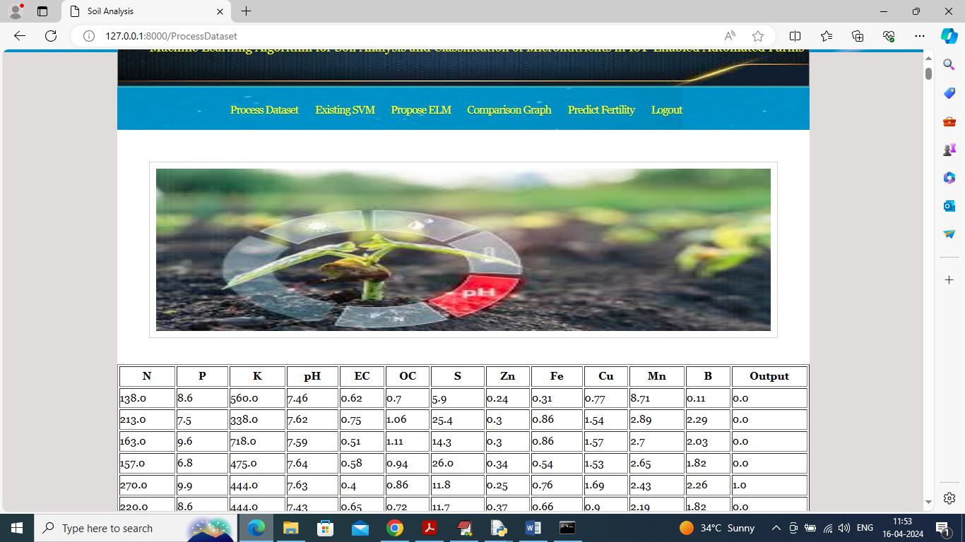

In above screen dataset loaded and can see all soil nutrients values and now click on ‘Existing SVM’ link to train SVM and get below output

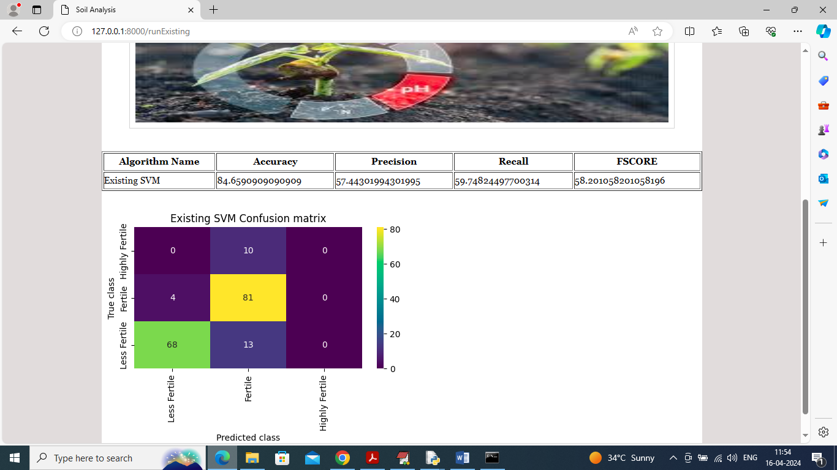

In above screen SVM training completed and can see accuracy as 84% and can see other metrics like precision, recall and FSCORE. In confusion matrix graph x-axis represents Predicted Labels and y-axis represents True Labels and then all different colour boxes in diagnol represents correct prediction count and remaining blue boxes represents incorrect prediction count which are very few and now click on ‘Propose ELM’ link to train propose model and get below page

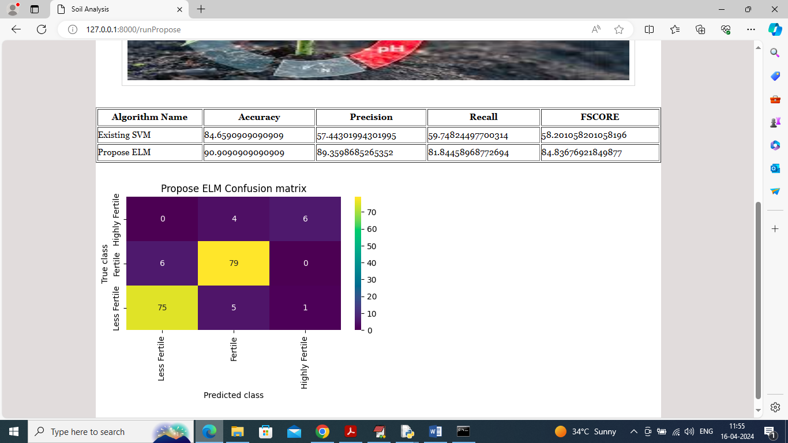

In above screen propose ELM got 90% accuracy and can see other metrics also and now click on ‘Comparison Graph’ link to get below page

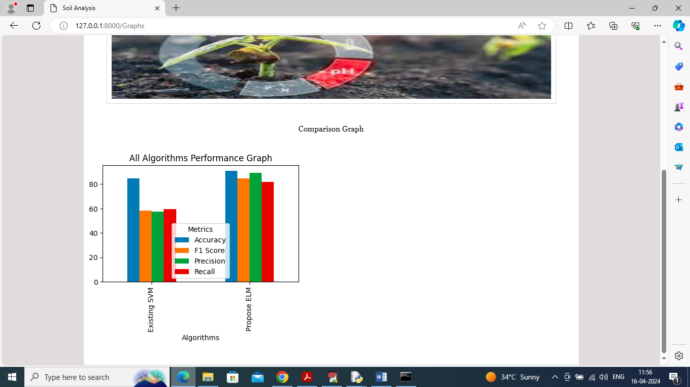

In above graph x-axis represents algorithm names and y-axis represents accuracy and other metrics in different colour bars and in both algorithms propose got high accuracy and now click on ‘Predict Fertility’ link to get below page

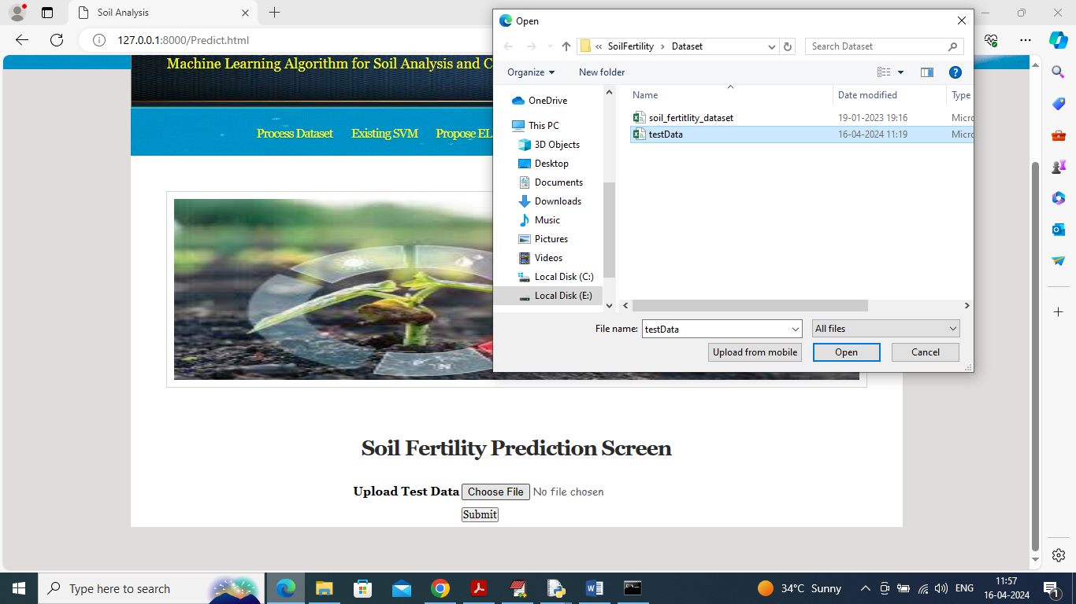

In above screen selecting and uploading ‘test data’ and then click on ‘Open’ and ‘Submit’ button to get below page

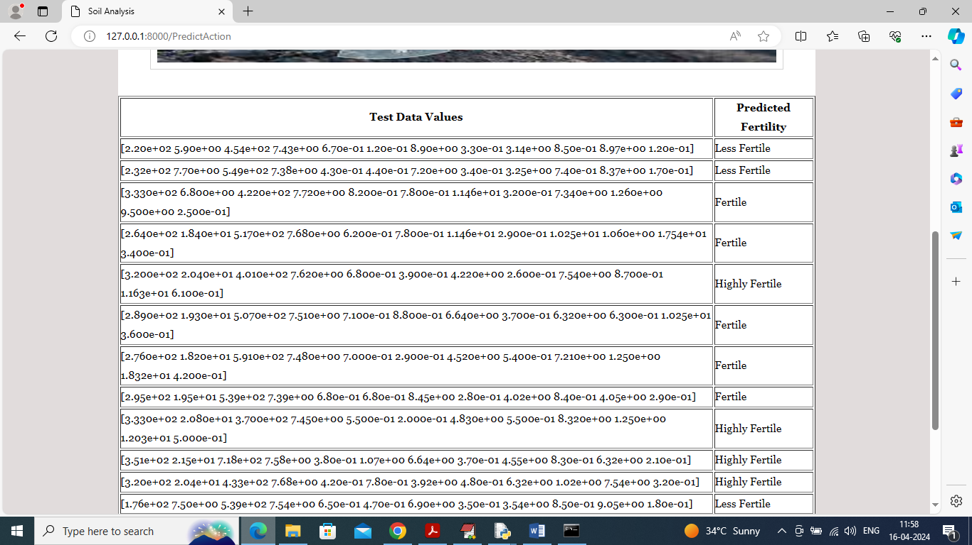

In above screen in first column can see soil test data and then in second column can see soil prediction as ‘High, low and medium’.

**Conclusion:**

The integration of IoT and machine learning for soil analysis and nutrient classification offers a transformative approach to precision agriculture, enabling farmers to monitor soil health in real-time and make informed decisions about nutrient management. By automating data collection through IoT sensors and utilizing advanced machine learning algorithms to classify soil nutrient levels, this system addresses many of the limitations of traditional soil testing methods. The proposed system provides immediate insights, allowing for timely interventions that optimize crop health, enhance yield, and support resource efficiency. This data-driven approach represents a significant shift from reactive to proactive soil management, where farmers can act swiftly to address nutrient deficiencies.

The high accuracy and adaptability of the machine learning models employed in this system make it a powerful tool for nutrient classification, even across diverse soil types and fluctuating environmental conditions. The ability to update and retrain the model over time ensures that the system remains relevant and effective, adjusting to seasonal changes and evolving agricultural needs. Moreover, the incorporation of explainable AI (XAI) techniques strengthens the system's transparency, helping farmers understand the basis of nutrient recommendations and building trust in automated decision-making processes. This emphasis on explainability not only fosters user adoption but also empowers farmers with the knowledge behind each recommendation, leading to better-informed soil management practices.

Beyond immediate benefits to productivity, this IoT-enabled and machine learning-driven system promotes sustainable agricultural practices by optimizing fertilizer usage and reducing the environmental impact of nutrient runoff and soil degradation. By precisely targeting nutrient needs, the system minimizes waste, conserves resources, and supports long-term soil health, aligning with the growing demand for eco-friendly farming solutions. As the agriculture industry continues to face challenges related to climate change, soil degradation, and resource scarcity, this technology offers a scalable, resilient solution that benefits both the farm and the environment.

In conclusion, the proposed system represents a comprehensive, scalable, and intelligent approach to soil nutrient management that integrates seamlessly into IoT-enabled automated farms. With its ability to provide real-time, accurate soil analysis and nutrient classification, this system empowers farmers to manage soil health effectively and sustainably. By bridging the gap between data collection and actionable insights, this solution enhances the productivity, efficiency, and sustainability of modern farming, offering a promising path forward for the future of precision agriculture.

**Future Work:**

While the proposed system offers a robust solution for real-time soil analysis and nutrient classification, there are several avenues for future work that could enhance its capabilities and applicability in precision agriculture. One promising direction is the development of more advanced machine learning models capable of handling complex, non-linear relationships between an even wider range of soil parameters and crop requirements. Techniques such as deep learning, ensemble methods, and hybrid algorithms could further improve prediction accuracy, particularly for farms with highly variable soil conditions or crops with unique nutrient needs. Additionally, incorporating weather forecasting data and crop growth models could help predict nutrient needs dynamically, allowing the system to provide nutrient recommendations based not only on current soil conditions but also on anticipated changes in the environment.

Another area for improvement lies in the use of low-cost, energy-efficient IoT sensors that could make the system more accessible and scalable for small and medium-sized farms. Developing sensors capable of detecting a broader range of nutrients and soil properties, such as microbial activity or organic content, could enhance the system’s ability to capture a more holistic view of soil health. Future work could explore strategies for sensor deployment optimization, including variable placement techniques and AI-driven mapping of sensor locations to ensure maximum coverage and data relevance. With these enhancements, the system would be better equipped to adapt to different farm configurations and soil compositions, supporting diverse agricultural needs.

Expanding the system’s explainable AI (XAI) capabilities is another important direction for future research. While current XAI techniques offer basic interpretability, future developments could focus on building more intuitive and user-friendly explanations tailored to farmers’ knowledge levels and decision-making needs. Providing interactive visualizations, trend analysis, and actionable insights could enhance user engagement and further build trust in the system’s recommendations. Additionally, incorporating feedback mechanisms that allow farmers to input observations or adjustments would enable a continuous learning loop, where the system refines its predictions and recommendations based on real-world outcomes.

The integration of blockchain or other decentralized data management technologies could also play a role in future iterations of the system. By securely recording and verifying soil health data and recommendations, blockchain can enhance data transparency, traceability, and accountability in the agricultural supply chain. This feature could be particularly valuable for organic or sustainably certified farms, where soil management practices must meet specific standards. Such integrations would not only improve data security but could also foster collaboration and data sharing among farms, research institutions, and policymakers, promoting collective advancements in soil health management.

Finally, future work should consider scalability and long-term sustainability to make the system viable across regions and farming scales. Developing adaptable software architectures that allow integration with diverse agricultural platforms and data sources, such as satellite imagery and remote sensing data, could expand the system’s usability beyond IoT-equipped farms. Collaboration with agricultural organizations and local governments could also facilitate wider adoption, especially in regions with limited resources. By continuously refining and adapting the system to meet evolving agricultural challenges, this technology has the potential to become a vital tool for improving global soil health, supporting food security, and advancing sustainable farming practices worldwide.

**References**

**Basso, B., & Wu, L. (2019**). The role of precision agriculture in sustainable farming. Agricultural Systems, 167, 22-29.

This study discusses how precision agriculture technologies, including IoT and machine learning, can enhance sustainability in farming practices. It emphasizes the importance of data-driven decision-making in optimizing resource use and improving crop productivity.

**Cao, Y., Yang, G., & Hu, Q. (2020).** A review of soil moisture and nutrient monitoring using wireless sensor networks. Sensors, 20(6), 1688.

This review paper explores the use of wireless sensor networks for monitoring soil moisture and nutrients. It provides insights into the technological advancements in sensor deployment and data collection, which are essential for real-time soil analysis in automated farming systems.

**Rana, D., Kumar, A., & Singh, G. (2021).** Machine learning applications in agriculture: A systematic review. Agricultural Systems, 184, 102901.

This systematic review examines various machine learning applications in agriculture, focusing on their potential to improve crop yield, soil health, and nutrient management. It highlights the challenges and opportunities of integrating machine learning with agricultural practices.

**Liu, J., Zhang, Y., & Ma, Y. (2022).** Deep learning for soil nutrient classification: A case study of multilayer perceptron model. Computers and Electronics in Agriculture, 191, 106525.

This research investigates the effectiveness of deep learning models, specifically multilayer perceptrons, in classifying soil nutrients. The findings underscore the potential of advanced machine learning techniques in improving the accuracy of soil nutrient assessments.

**Tiwari, S., Shukla, A., & Agrawal, R. (2021).** Internet of Things (IoT) and agriculture: A review of current and future applications. Journal of Soil and Water Conservation, 76(2), 101-113.

This review article discusses the intersection of IoT and agriculture, providing insights into current applications, challenges, and future directions for IoT technologies in enhancing agricultural efficiency and sustainability.

**Zhao, Y., Chen, X., & Liu, H. (2023).** Enhancing soil nutrient monitoring through machine learning and IoT technologies. Sensors and Actuators B: Chemical, 366, 132017.

This study explores the integration of machine learning with IoT technologies for improving soil nutrient monitoring. The authors highlight the benefits of real-time data processing and analysis in promoting efficient nutrient management strategies.

**Bong, Y., & Kim, D. (2020).** The potential of machine learning in soil health assessment: A review. Geoderma, 361, 114050.

This comprehensive review examines the role of machine learning in assessing soil health, with a focus on its applications in nutrient classification and management. The paper discusses various algorithms and their effectiveness in predicting soil properties.

**Ghosh, A., & Roy, A. (2021).** IoT-based soil monitoring system for precision agriculture: A case study. Journal of Ambient Intelligence and Humanized Computing, 12(2), 1979-1991.

This case study showcases an IoT-based soil monitoring system that utilizes sensor data for precision agriculture. The authors demonstrate the system's effectiveness in providing real-time soil analysis and nutrient recommendations.

**Kumar, V., & Gupta, A. (2022).** Exploring the use of explainable AI in agriculture: Opportunities and challenges. Computers and Electronics in Agriculture, 193, 106666.

This article discusses the application of explainable AI techniques in agriculture, emphasizing their potential to enhance transparency and user trust in automated decision-making systems for nutrient management.

**Zhou, W., Zhang, R., & Wang, Z. (2022**). Adopting machine learning for soil quality assessment: Trends and future prospects. Environmental Research Letters, 17(10), 103008.

This paper reviews the trends in machine learning applications for soil quality assessment, highlighting future research directions and the importance of integrating diverse data sources for comprehensive soil health evaluations.